|  |
| --- |
|  |
| Capstone Project Document |

**BOOKAHOLIC SOCIAL NETWORK**

Report #2 – Class Design

|  |  |  |
| --- | --- | --- |
| **Bookaholic Social Network** | | |
| **Group Members** | Phạm Thị Huyền | SE03416 |
| Thái Thị Cẩm Vân | SE03409 |
| Vũ Hải Đăng | SE03380 |
| Nguyễn Thị Hải Yến | SE03171 |
| Chu Minh Hải | SE03143 |
| **Supervisor** | Mr. Nguyễn Văn Sang | |
| **Project code** | BSN | |

**- Hanoi, 10/2016 -**

# SIGNATURE PAGE

AUTHOR: Phạm Thị Huyền --/--/2016

Project manager

REVIEWERS: --/--/2016

Team member

APPROVAL: Nguyễn Văn Sang --/--/2016

Supervisor

Record of change

*A - Added M - Modified D – Deleted

|  |  |  |  |  |  |
| --- | --- | --- | --- | --- | --- |
| Effective Date | Changed Item | A,M,D | Change Description | Reason for Change | Rev. Number |
|  |  |  |  |  |  |
|  |  |  |  |  |  |
|  |  |  |  |  |  |

TABLE CONTENTS

SIGNATURE PAGE 0

Introduction 2

1.1 Purpose 2

1.2 Definitions, Acronyms and Abbreviations 2

2 Package 2

2.1 Package Diagram 2

2.2 Package Description 3

2.2.1 Model 3

2.2.2 0

3 Function 0

3.1 Guest Module 0

3.1.1 Register 0

3.2 Reader/Author Module 0

3.2.1 Account 0

3.2.2 Post 1

3.2.3 Interaction 3

3.2.4 Group 3

3.2.5 Book 4

3.3 Admin Module 4

3.3.1 User Accounts Management 4

3.3.2 Groups Management 4

3.3.3 Books Management 5

3.3.4 Sliders Management 0

3.3.5 Publishers Management 4

3.3.6 Statistics 7

# Introduction

## Purpose

BSN class design document contains descriptions of all classes of the BSN. It includes: Class diagrams that describe the static relation of all classes in the system.

## Definitions, Acronyms and Abbreviations

|  |  |  |
| --- | --- | --- |
| Abbreviations | Description | Note |
| BSN | Bookaholic Social Network |  |
|  |  |  |

1. Definitions, Acronyms and Abbreviations

# Package

## Package Diagram

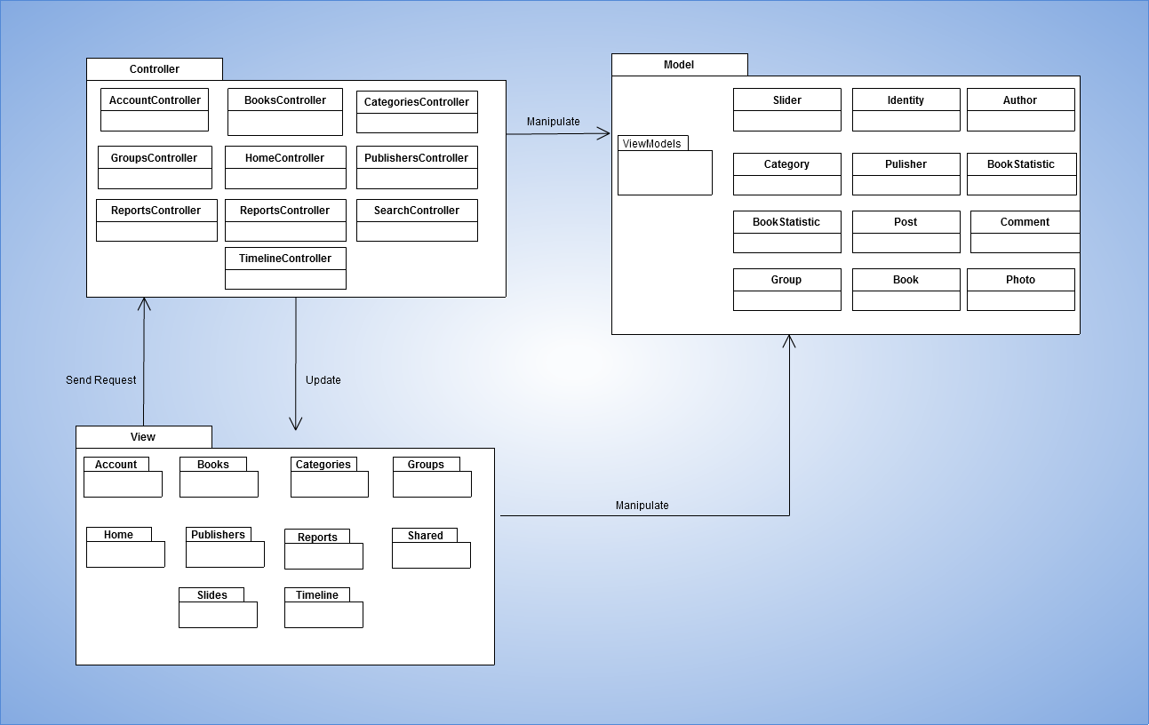

1. Package Diagram

## Package Description

### Model

#### BSN_User

|  |  |  |  |  |  |
| --- | --- | --- | --- | --- | --- |
| **No** | **Field Name** | **Type** | **Default** | **Note** | **Description** |
|  | _id | ObjectId |  | Public | Mongodb objectid  Unique for each document |
|  | UserName | String |  | Public | User’s name |
|  | Email | String |  | Public | User’s Email |
|  | EmailConfirmed | Boolean |  | Public | Status of registration confirmation via email |
|  | PasswordHash | String |  | Public | Password encrypt by SHA 256 |
|  | Role | String |  | Public | User’s role |
|  | Gender | String |  | Public | User’s gender |
|  | Avatar | String |  | Public | Publicid of user’s avatar in cloudinary |
|  | Cover | String |  | Public | Publicid of user’s cover in cloudinary |
|  | DOB | DateTime |  | Public | User’s date of birth |
|  | Address | String |  | Public | User’s address |
|  | SSNImgId | String |  | Public | User’s SSN image publicid in cloudinary |

#### Post

|  |  |  |  |  |  |
| --- | --- | --- | --- | --- | --- |
| **No** | **Field Name** | **Type** | **Default** | **Note** | **Description** |
| 1 | _id | ObjectId |  | Public |  |
| 2 | Content | String |  | Public |  |
| 3 | PostedBy | String |  | Public |  |
| 4 | PostedDate | DateTime |  | Public |  |
| 5 | BookTag | Array[String] |  | Public | List of book taged in user’s posst |

#### Book

|  |  |  |  |  |  |
| --- | --- | --- | --- | --- | --- |
| **No** | **Field Name** | **Type** | **Default** | **Note** | **Description** |
| 1 | _id | ObjectId |  | Public | Mongodb objectid  Unique for each document |
| 2 | BookName | String |  | Public | Book’s name |
| 3 | ImgPublicId | String |  | Public | Book’s image publicid in cloudinary |
| 4 | ReleaseDay | DateTime |  | Public | Date of book release |
| 5 | Url | String |  | Public | Link detail of book |
| 6 | Description | String |  | Public | Content of book |
| 7 | RateTime | Int |  | Public | Sum rating point of each rate |
| 8 | RatingPoint | Int |  | Public | Sum rating time |
| 9 | AvarageRating | Double |  | Public | RatingPoint/RateTime |

#### Category

|  |  |  |  |  |  |
| --- | --- | --- | --- | --- | --- |
| **No** | **Field Name** | **Type** | **Default** | **Note** | **Description** |
| 1 | _id | ObjectId |  | public | Mongodb objectid  Unique for each document |
| 2 | Name | String |  | public | Category’s name |

#### Author

|  |  |  |  |  |  |
| --- | --- | --- | --- | --- | --- |
| **No** | **Field Name** | **Type** | **Default** | **Note** | **Description** |
| 1 | _id | ObjectId |  | Public | Mongodb objectid  Unique for each document |
| 2 | UserId | ObjectId |  | Public | User’s id |
| 3 | AuthorName | String |  | Public | Name of Author |
| 4 | RatingPoint | Double |  | Public | Author’s rating point |

#### Publisher

|  |  |  |  |  |  |
| --- | --- | --- | --- | --- | --- |
| **No** | **Field Name** | **Type** | **Default** | **Note** | **Description** |
| 1 | _id | ObjectId |  | Public | Mongodb objectid  Unique for each document |
| 2 | Name | String |  | Public | Publisher’s name |
| 3 | PhoneNumber | String |  | Public | Publisher’s phone number |
| 4 | ImagePublicId | String |  | Public | Publisher’s image publicid in cloudinary |
| 5 | Address | String |  | Public | Publisher’s address |

#### Reports

|  |  |  |  |  |  |
| --- | --- | --- | --- | --- | --- |
| **No** | **Field Name** | **Type** | **Default** | **Note** | **Description** |
| 1 | _id | ObjectId |  | Public | Mongodb objectid  Unique for each document |
| 2 | UserId | ObjectId |  | Public | User’s id |
| 3 | GroupId | ObjectId |  | Public | Group’s id |
| 4 | Reporteduserid | ObjectId |  | Public | Id of user reported |
| 5 | Reportedgroupid | ObjectId |  | Public | Id of group reported |
| 6 | Content | String |  | Public | Content of report |
| 7 | Status | Boolean |  | Public |  |

#### Group

|  |  |  |  |  |  |
| --- | --- | --- | --- | --- | --- |
| **No** | **Field Name** | **Type** | **Default** | **Note** | **Description** |
| 1 | _id | ObjectId |  | Public | Mongodb objectid  Unique for each document |
| 2 | GroupName | String |  | Public | Book’s name |
| 3 | Locked | Boolean |  | Public | Status of group(lock or not) |
| 4 | GroupType | String |  | Public | Group’s type |
| 5 | CreateDate | DateTime |  | Public | Date time group created |
| 6 | Tag | String |  | Public | Group’s tag(author’s name or book’s name) |
| 7 | CreaterId | String |  | Public | Id of user that created group |
| 8 | Description | String |  | Public | Content of group |
| 9 | CoverImg | String |  | Public | Group cover’s image public id in cloudinary |
| 10 | AvaImg | String |  | Public | Group avatar’s image public id in cloudinary |

#### Slider

|  |  |  |  |  |  |
| --- | --- | --- | --- | --- | --- |
| **No** | **Field Name** | **Type** | **Default** | **Note** | **Description** |
| 1 | _id | ObjectId |  | Public | Mongodb objectid  Unique for each document |
| 2 | ImagePublicId | String |  | Public | Slide’s image publicid in cloudinary |
| 3 | Description | String |  | Public | Content of slide |
| 4 | Status | Boolean | True | Public | Slide’s status (show or not show) |

#### Book Statistic

|  |  |  |  |  |  |
| --- | --- | --- | --- | --- | --- |
| **No** | **Field Name** | **Type** | **Default** | **Note** | **Description** |
| 1 | _id | ObjectId |  | Public | Mongodb objectid  Unique for each document |
| 2 | BookId | String |  | Public | Book’s id |
| 3 | EachDate | DateTime |  | Public |  |
| 4 | Count | int |  | Public |  |

### View

Contain many .cshtml files to display user interface.

### Controller

#### AccountController

|  |  |  |  |  |
| --- | --- | --- | --- | --- |
| No | Method | Parameter | Return | Description |
|  | AccountController |  |  |  |
|  | AccountController | + userManager : ApplicationUserManager |  |  |
|  | Login | + returnUrl : string | ActionResult |  |
|  | Login | + model : AccountViewModel  + returnUrl : string | async |  |
|  | Register |  | ActionResult |  |
|  | AuthorRegister |  | ActionResult |  |
|  | Register | model : AccountViewModel | async |  |
|  | AuthorRegister | model : AccountViewModel | async |  |
|  | ConfirmEmail | + userId : string  + code : string | async |  |
|  | ForgotPassword |  | ActionResult |  |
|  | ForgotPassword | model : AccountViewModel | async |  |
|  | ForgotPasswordConfirmation |  | ActionResult |  |
|  | ResetPassword | code : string | [AllowAnonymous] |  |
|  | ResetPassword | model : ResetPasswordViewModel | async |  |
|  | ResetPasswordConfirmation |  | ActionResult |  |
|  | Disassociate | + loginProvider : string  + providerKey : string | [HttpPost][ValidateAntiForgeryToken] |  |
|  | Manage | message : ManageMessageId | ActionResult |  |
|  | Manage | model : ManageUserViewModel | async |  |
|  | ExternalLogin | + provider : string  + returnUrl : string | ActionResult |  |
|  | ExternalLoginCallback | returnUrl : string | async |  |
|  | LinkLogin | provider : string | ActionResult |  |
|  | LinkLoginCallback |  | async |  |
|  | ExternalLoginConfirmation | + model : ExternalLoginConfirmationViewModel  + returnUrl : string | async |  |
|  | LogOff |  | ActionResult |  |
|  | ExternalLoginFailure |  | ActionResult |  |
|  | RemoveAccountList |  | ActionResult |  |
|  | Users | + searchString : strin  + currentFilter : string, page : int | ActionResult Authors |  |
|  | Authors | + searchString : string  + currentFilter : string, page : int | ActionResult |  |
|  | AuthorConfirm | id : string | async |  |
|  | Dispose | disposing : bool | void |  |
|  | SignInAsync | + user : ApplicationUser  + isPersistent : bool | async |  |
|  | AddErrors | esult : IdentityResult | void |  |
|  | HasPassword |  | bool |  |
|  | RedirectToLocal | returnUrl : string | ActionResult |  |

#### Book Controller

|  |  |  |  |  |
| --- | --- | --- | --- | --- |
| No | Method | Parameter | Return | Description |
| 1 | Index | + searchString : string  + currentFilter : string  + page : int | ActionResult |  |
| 2 | Details | id : string | ActionResult |  |
| 3 | Create |  | ActionResult |  |
| 4 | Create | book : Book | ActionResult |  |
| 5 | Edit | id : string | ActionResult |  |
| 6 | Edit | book : Book | ActionResult |  |
| 7 | DeleteConfirm | id : string | ActionResult |  |
| 8 | RatingBook | + id : string  + rating : int | ActionResult |  |
| 9 | CommentBook | + commentedUser : string  + bookId : string  + commentContent : string | ActionResult |  |
| 10 | BookRequest | searchString : string | ActionResult |  |
| 11 | RequestAddBook | + bookName : string  + author : string  + categories : string | ActionResult |  |

#### Category Controller

|  |  |  |  |  |
| --- | --- | --- | --- | --- |
| No | Method | Parameter | Return | Description |
| 1 | Index |  | ActionResult |  |
| 2 | Create | categoryName : string | ActionResult |  |
| 3 | Edit | id : string | ActionResult |  |
| 4 | Edit | category : Category | ActionResult |  |
| 5 | Delete | id : string | ActionResult |  |
| 6 | DeleteConfirm | id : string | ActionResult |  |

#### Group Controller

|  |  |  |  |  |
| --- | --- | --- | --- | --- |
| No | Method | Parameter | Return | Description |
|  | GetUserForAdd | + selectedValues : string [][]  + groupId : string | MultiSelectList |  |
|  | GroupReportContent |  | List<string> |  |
|  | Index | + searchString : string  + currentFilter : string  + page : int | ActionResult |  |
|  | Lock | + id : string  + option : int  + reportId : string | ActionResult |  |
|  | MainPage | id : string | ActionResult |  |
|  | Members | id : string | ActionResult |  |
|  | GroupRequestHandle | + groupId : string  + userId : string  + option : int | ActionResult |  |
|  | Setting | id : string | ActionResult |  |
|  | Setting | groupSetting : GroupSettingViewModel | ActionResult |  |
|  | Details | id : int | ActionResult |  |
|  | Create |  | ActionResult |  |
|  | Create | + groupName : string  + groupTag : string  + groupDesc : string  + groupType : string | ActionResult |  |
|  | Edit | id : int | ActionResult |  |
|  | Edit | + id : int  + collection : FormCollection | ActionResult |  |
|  | Delete | id : int | ActionResult |  |
|  | Delete | + id : int  + collection : FormCollection | ActionResult |  |
|  | ChangeImage | + id : string  + file : HttpPostedFileBase  + option : int | ActionResult |  |
|  | Report |  | ActionResult |  |
|  | AddNewMember | + addUser : string  + groupId : string | ActionResult |  |

#### Home Controller

|  |  |  |  |  |
| --- | --- | --- | --- | --- |
| No | Method | Parameter | Return | Description |
|  | Index |  | ActionResult |  |
|  | GetListBookTag | input : string | ActionResult |  |
|  | LockedPage |  | ActionResult |  |

#### Timeline Controller

|  |  |  |  |  |
| --- | --- | --- | --- | --- |
| No | Method | Parameter | Return | Description |
|  | Details | id : string | ActionResult |  |
|  | EditProfile | id : string | ActionResult |  |
|  | EditProfile | user : UserProfile | async |  |
|  | ChangeImage | + id : string  + file : HttpPostedFileBase, option : int | ActionResult |  |
|  | FollowHandle | + followerId : string  + followedUserId : string  + option : int | ActionResult |  |
|  | Lock | + id : string  + option : int  + reportId : string | ActionResult |  |

#### Report Controller

|  |  |  |  |  |
| --- | --- | --- | --- | --- |
| No | Method | Parameter | Return | Description |
|  | Index | page : int | ActionResult |  |
|  | GetReport | + reportContent : string  + userId : string  + beReportedId : string  + option : int | ActionResult |  |

#### Publisher Controller

|  |  |  |  |  |
| --- | --- | --- | --- | --- |
| No | Method | Parameter | Return | Description |
| 1 | Get | page : int | ActionResult | Get list publishers |
| 2 | Upload | publisher : Publisher | ActionResult | Upload new publisher |
| 3 | Delete | id : string | ActionResult | Delete a publisher |
| 4 | Edit | publisher : Publisher | ActionResult | Edit a publisher’s information |

#### Slider Controller

|  |  |  |  |  |
| --- | --- | --- | --- | --- |
| No | Method | Parameter | Return | Description |
| 1 | Get | page : int | ActionResult | Get list sliders |
| 2 | Upload | desc : string | ActionResult | Upload new slider |
| 3 | Delete | id : string | ActionResult | Delete a slider |
| 4 | Show | id : string | ActionResult | Show sliders on register page |

# Function

## Guest Module

### Register

#### Class diagram

#### Sequence diagram

##### Register for a normal account

##### Register for an author account

## Reader/Author Module

### Account

#### Class diagram

#### Sequence diagram

##### Login

##### Logout

##### Edit personal information

##### Edit avatar and cover photo

##### Reset password

### Post

#### Class diagram

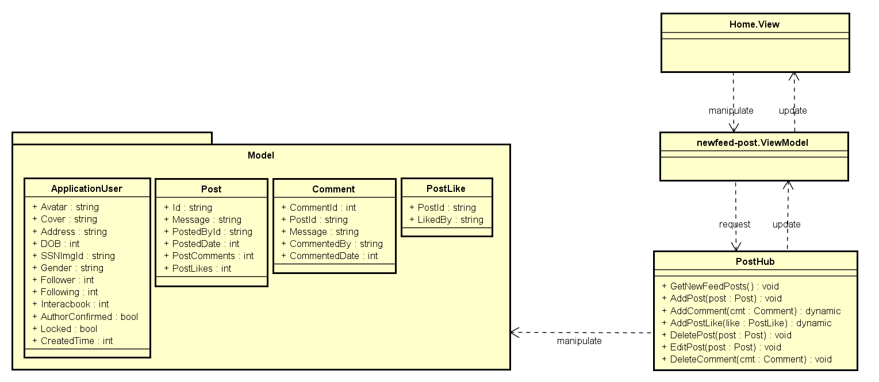

Figure 3‑1: Post Class Design

#### Sequence diagram

##### Create a post

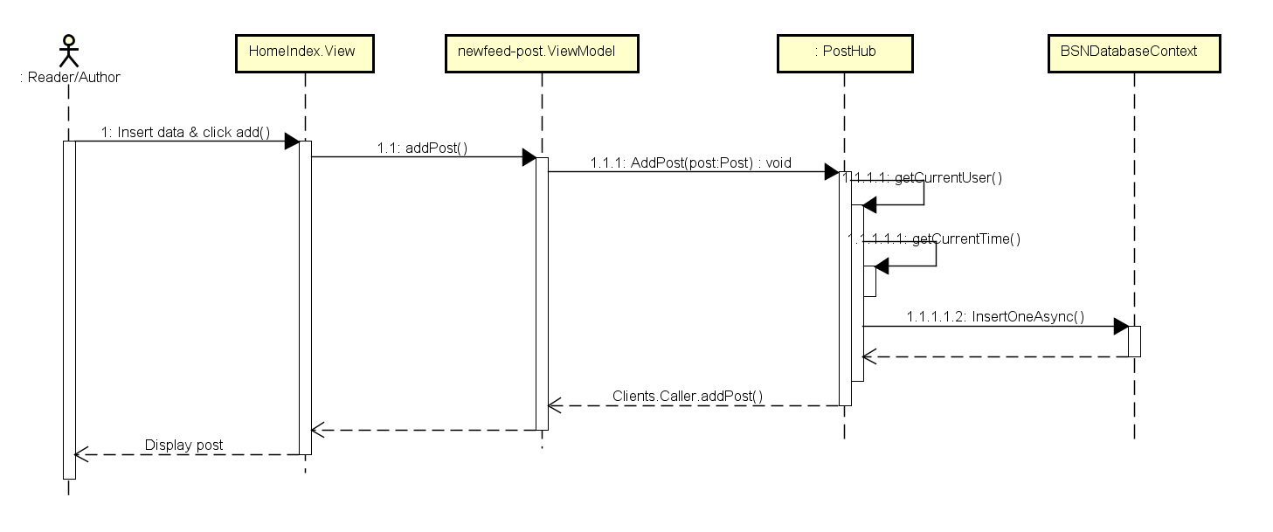

Figure 3‑2: Create Post Sequence Diagram

##### Edit a post

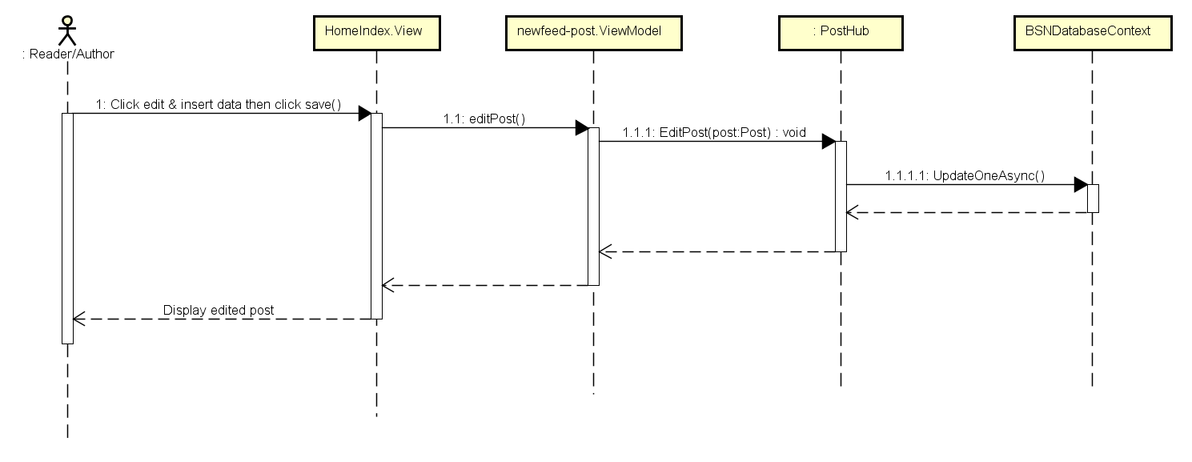

Figure 3‑3: Edit Post Sequence Diagram

##### Delete a post

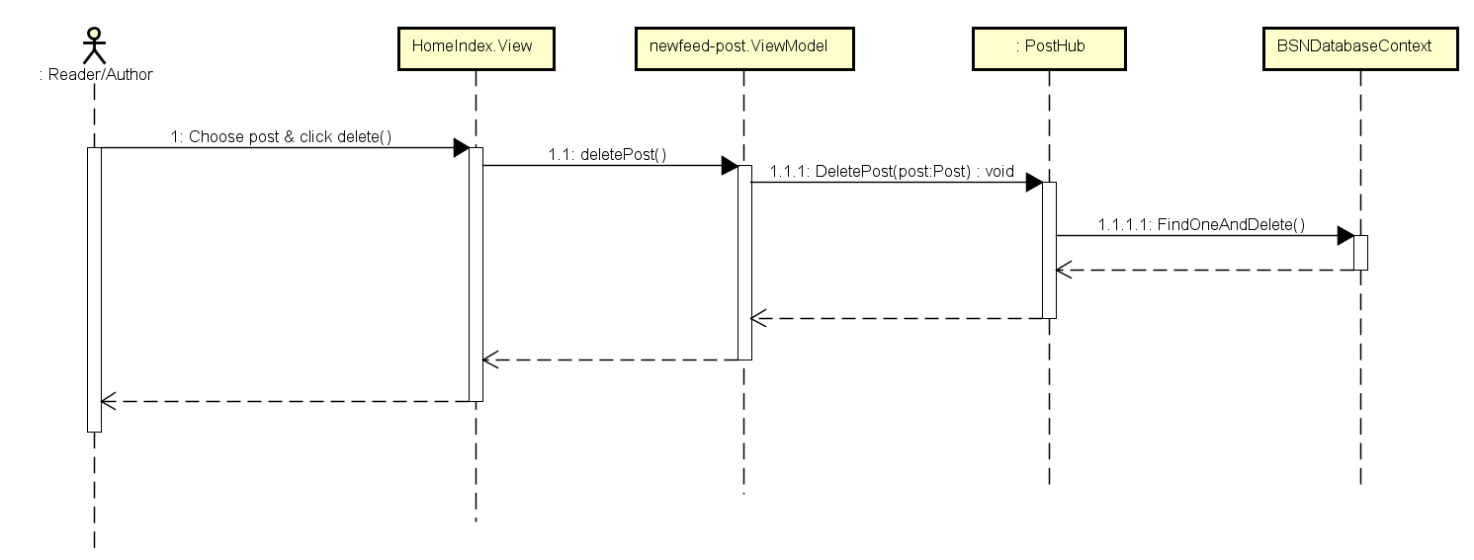

Figure 3‑4: Delete Post Sequence Diagram

##### Like a post

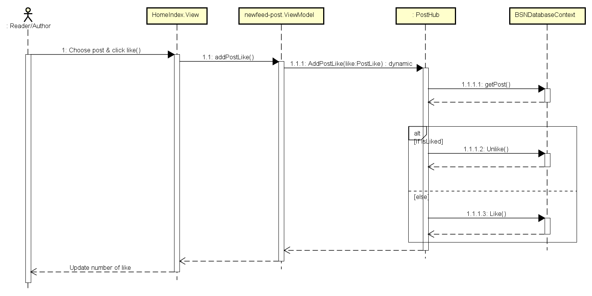

Figure 3‑5: Like Post Sequence Diagram

##### Unlike a post

Refer figure 3.2.2.2.4

##### Comment on a post

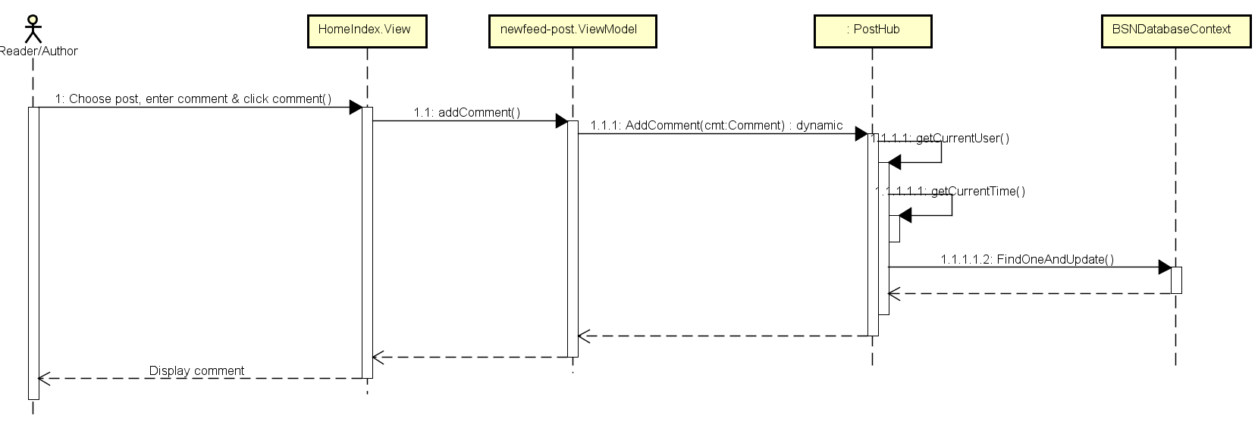

Figure 3‑6: Comment on Post Sequence Diagram

##### Delete a comment

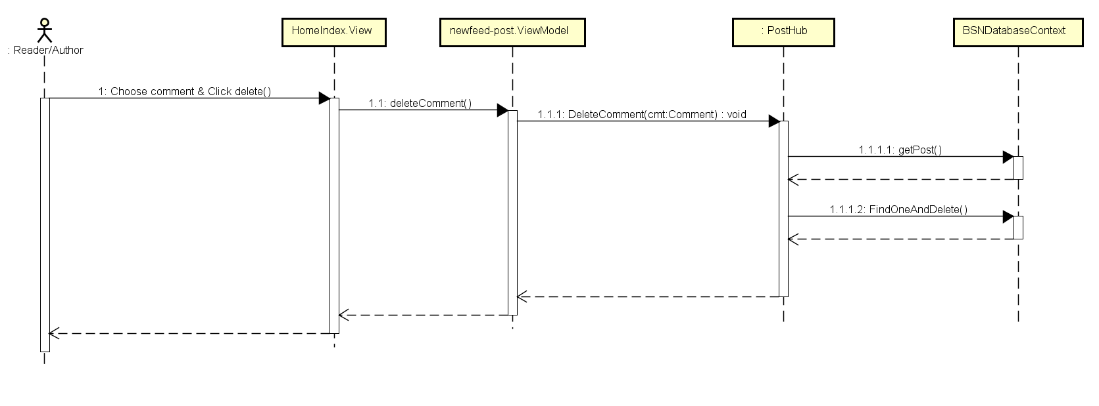

Figure 3‑7: Delete Comment Sequence Diagram

### Interaction

#### Class diagram

#### Sequence diagram

##### Follow user account

##### Report user account

##### Send join-group request

##### Leave a group

##### Report a group

##### Get Notification

### Group

#### Class diagram

#### Sequence diagram

##### Create a group

##### Edit group information

##### Edit group's avatar/cover photo

##### Add new members

##### Accept join-group request

##### Set group's admin

##### Remove a member

##### Create a group post

##### Like a group post

##### Edit a group post

##### Delete a group post

##### Comment on a group post

##### Delete comment on a group post

### Book

#### Class diagram

#### Sequence diagram

##### Rate a book

##### Comment on a book

##### View a book's details

##### Search book/author/other account/group

##### View suggested books/authors

## Admin Module

### User Accounts Management

#### Class diagram

#### Sequence diagram

##### Search user

##### Ban user

##### Unban user

##### Decline request about reporting an account

##### Accept request about creating author account

##### Decline request about creating author account

### Groups Management

#### Class diagram

#### Sequence diagram

##### Band a group

##### Unban a group

##### Decline request about reporting a group

### Books Management

#### Class diagram

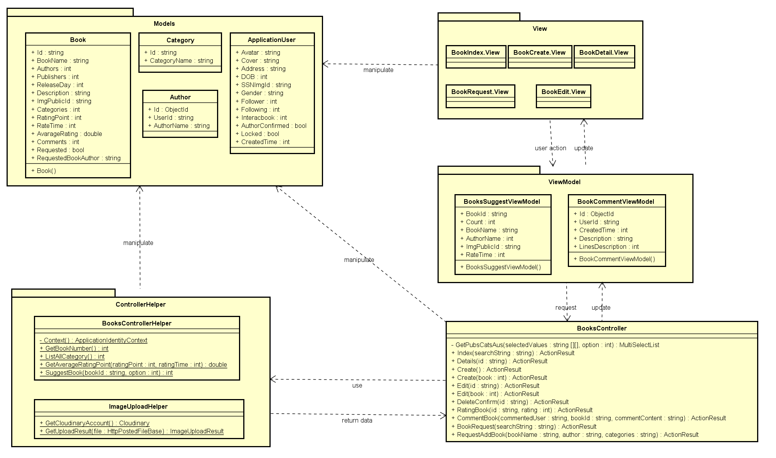

Figure 3‑8: Book Management Class Diagram

#### Sequence diagram

##### Add a new book

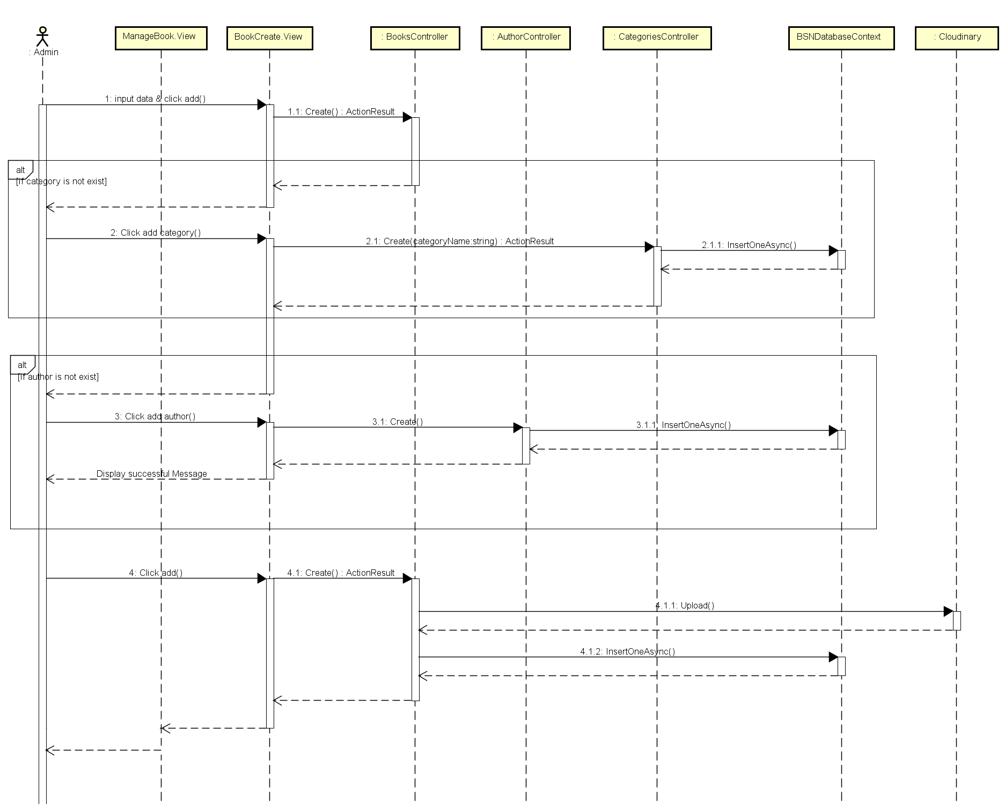

Figure 3‑9: Add Book Sequence Diagram

##### Add a new Category

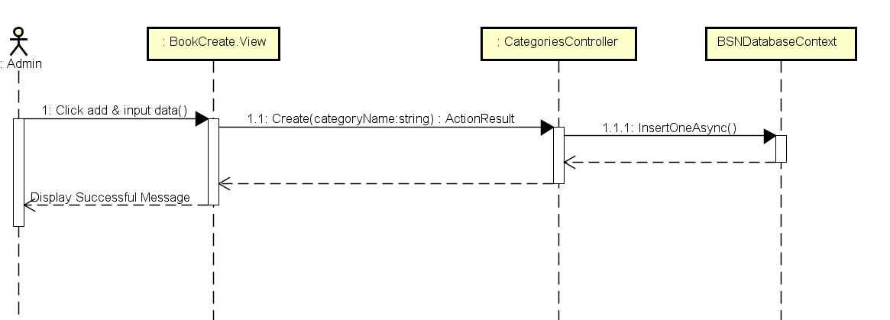

Figure 3‑10: Add Category Sequence Diagram

##### Add an author

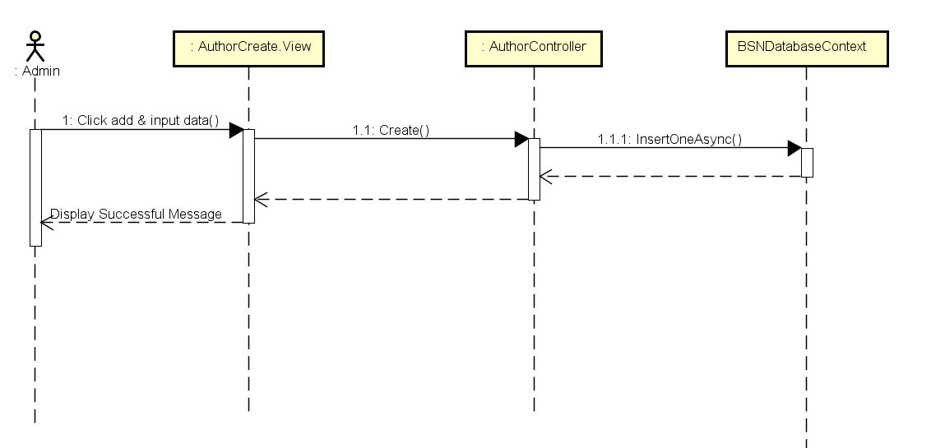

Figure 3‑11: Add Author Sequence Diagram

##### Edit book's information

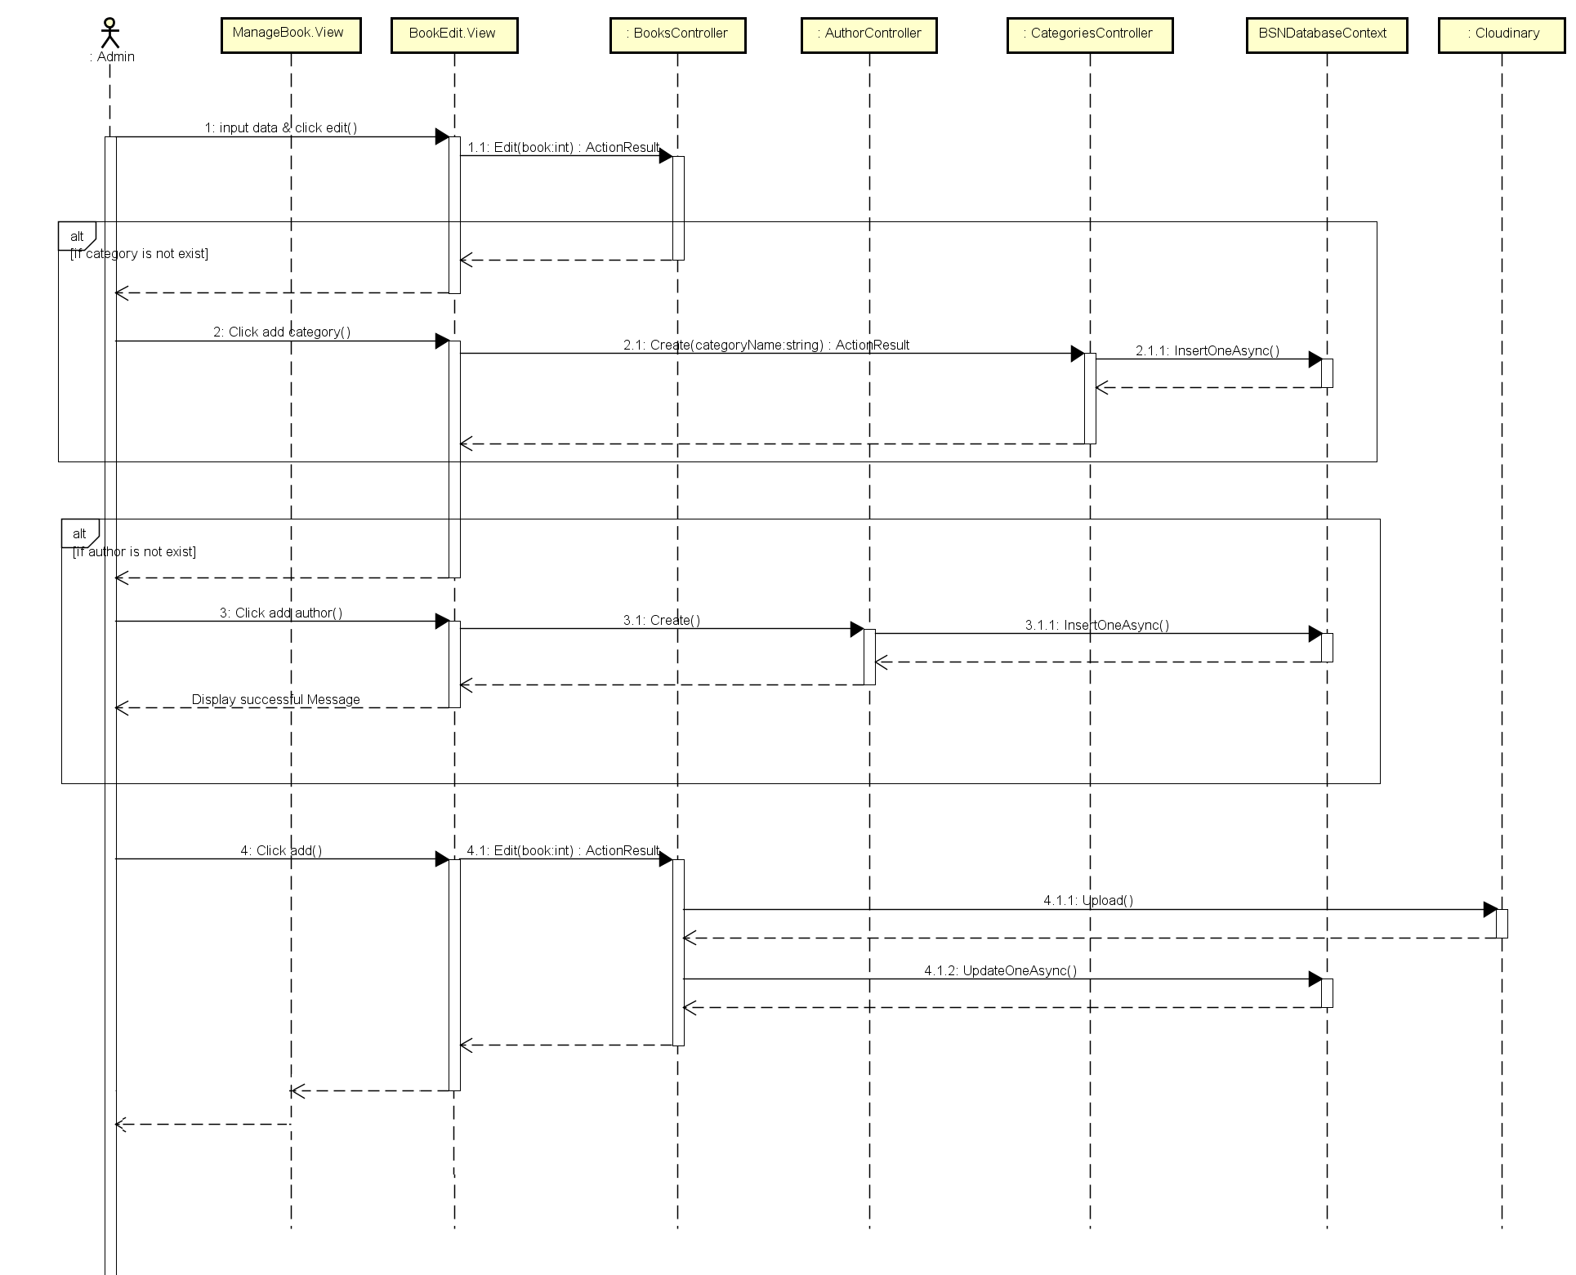

Figure 3‑12: Edit Book Sequence Diagram

##### Accept add-book request

##### Decline add-book request

### Sliders Management

#### Class diagram

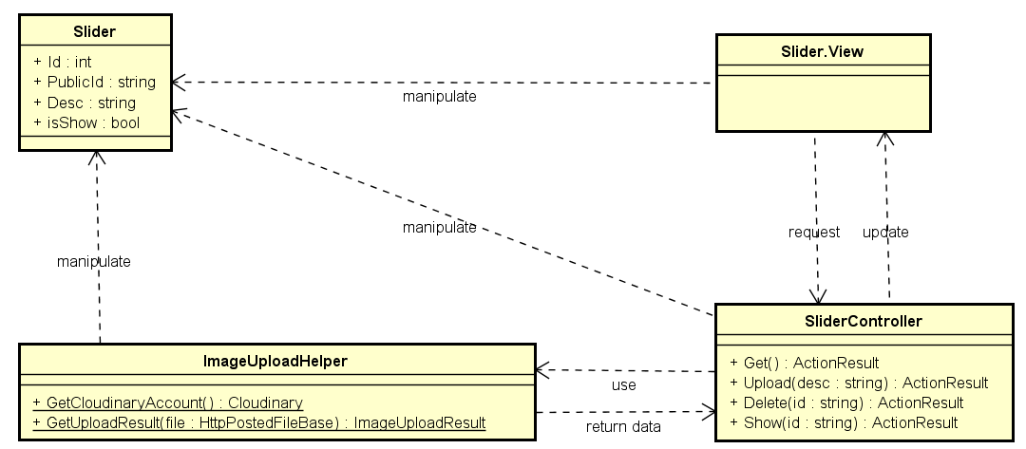

Figure 3‑13: Slider Management Class Diagram

#### Sequence diagram

##### Add a slider

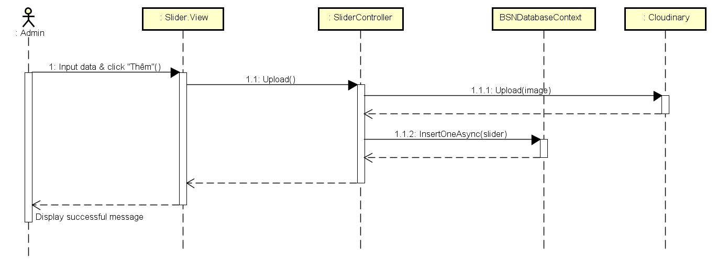

Figure 3‑14: Add Slider Sequence Diagram

##### Delete a slider

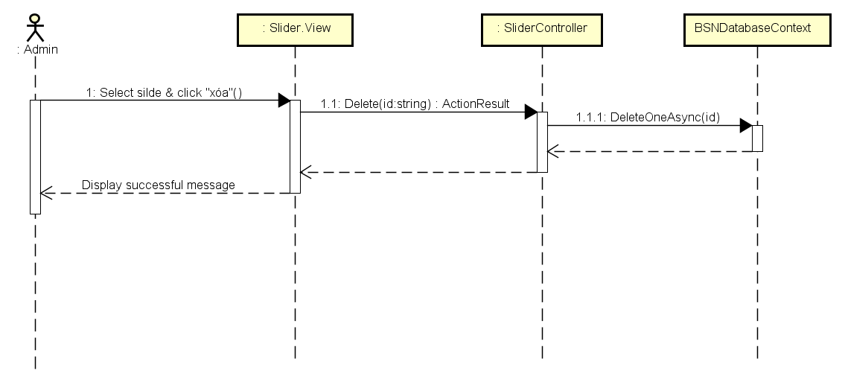

Figure 3‑15: Delete Slider Sequence Diagram

##### Active/de-active a slider

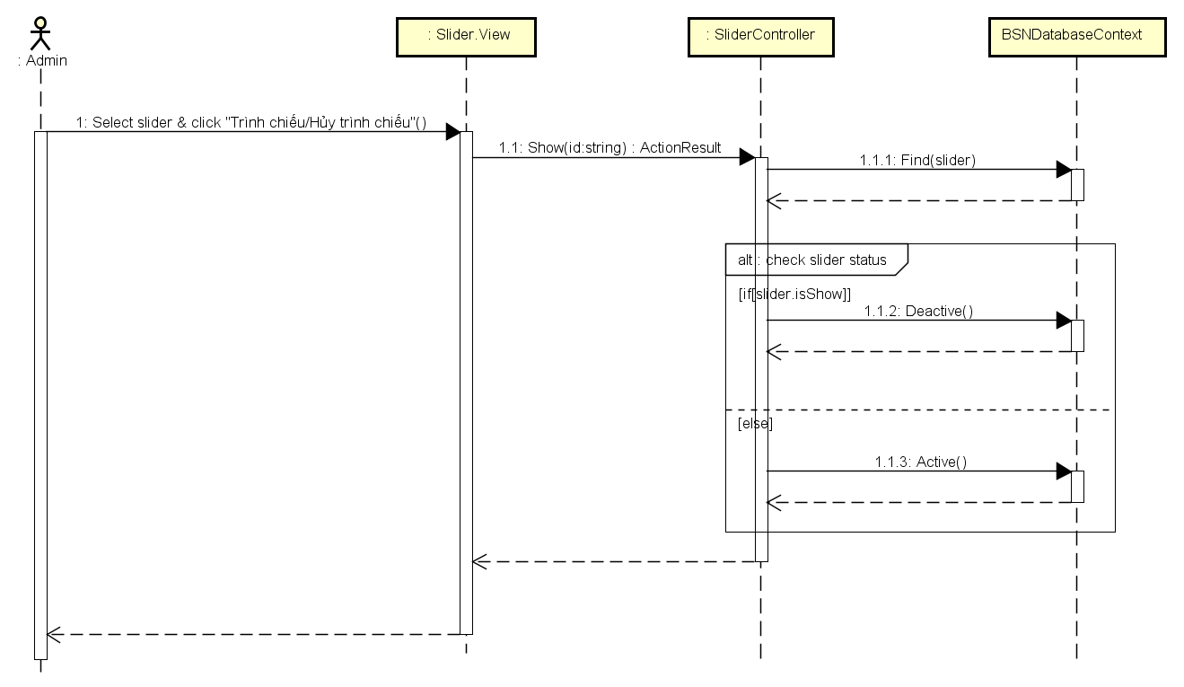

Figure 3‑16: Active/De-active Slider Sequence Diagram

##### Show sliders

### Publishers Management

#### Class diagram

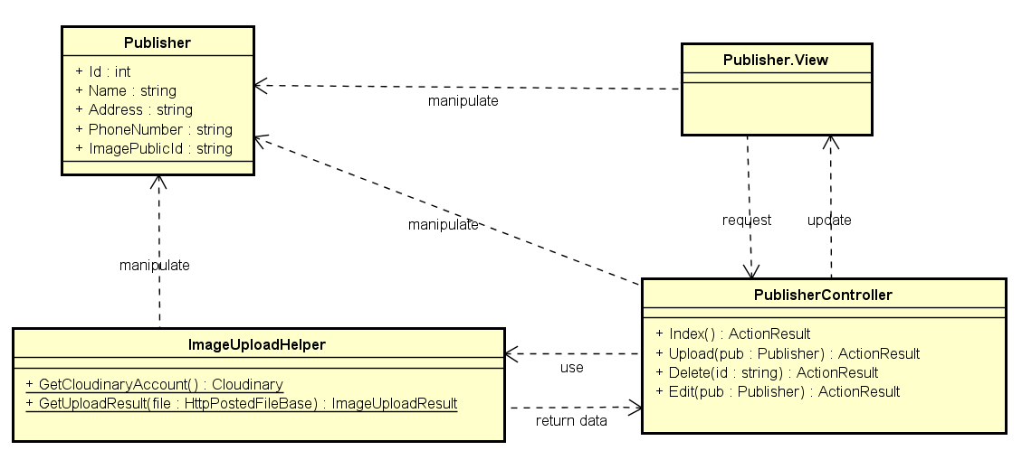

Figure 3‑17: Publisher Management

#### Sequence diagram

##### Add a new publisher

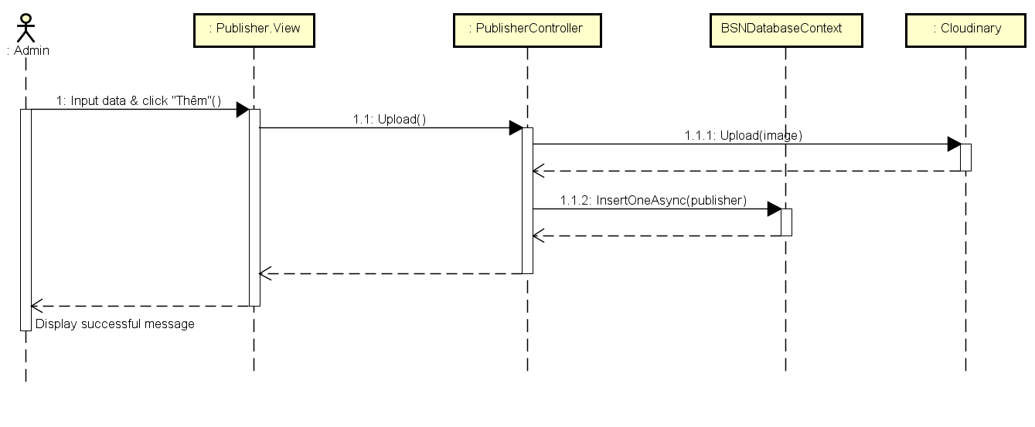

Figure 3‑18: Add publisher Sequence Diagram

##### Edit publisher' information

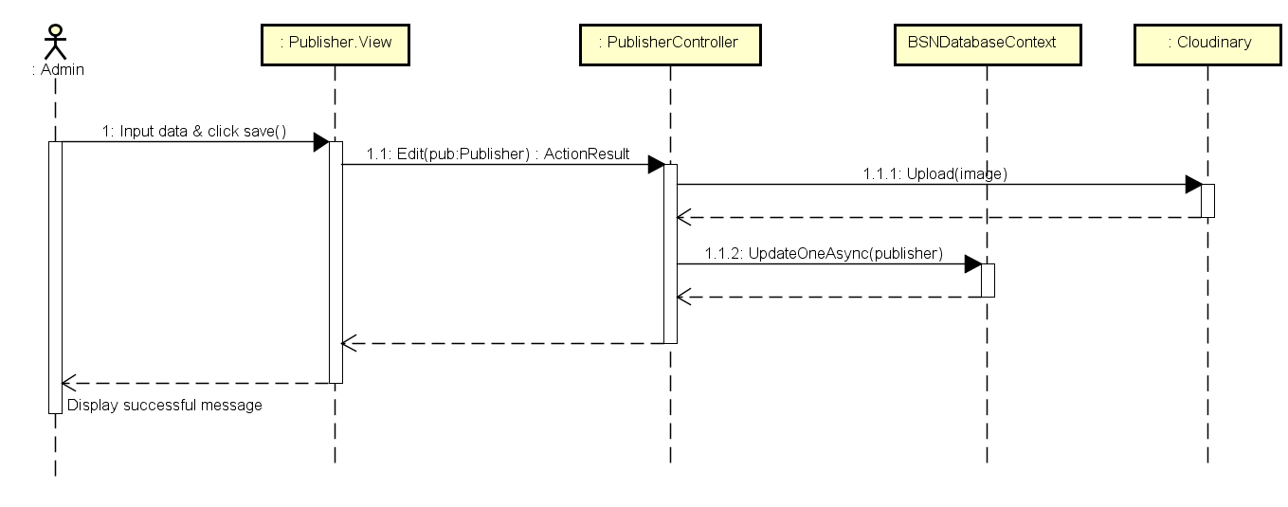

Figure 3‑19: Edit Publisher Sequence Diagram

##### Delete a publisher

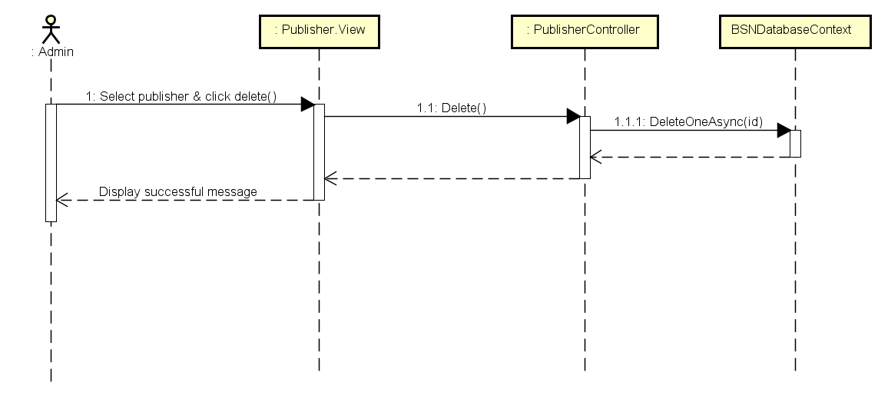

Figure 3‑20: Delete Publisher Sequence Diagram

### Statistics